⸻

🐾 Kyra Kennels – Preserving the Legacy of the Tibetan Mastiff

Kyra Kennels was founded over 20 years ago with a deep passion for the preservation of the ancient Tibetan Mastiff. Kyra kennels started out as a vision of my late father Col.Kuldeep Singh

Over the last decade, we have witnessed the breed face a downward trajectory due to increasing market demand, careless breeding practices, and the dilution of original bloodlines. What was once a majestic guardian of the Tibetan Plateau began losing its true essence.

Our mission remains clear — to restore this magnificent breed to its former glory.

We carefully handpick our lines directly from the Tibetan Plateau and the historic Hequ region, working closely with dedicated breeders who share our commitment to authenticity and preservation. Our focus is on safeguarding some of the oldest and purest bloodlines that still exist.

Our gene pool proudly carries some of the most recognized and respected lines, including Panda, Jin Tai, and traditional Tibetan lines. However, beyond names and recognition, our breeding philosophy centers on:
• Health
• Correct structure
• Sound temperament
• Functional movement
• True breed type

We believe preservation is not just about breeding dogs — it is about protecting heritage, culture, and genetic integrity.

Kyra Kennels is built on teamwork and dedication. Our core members who contribute to this journey include:

Avtar Singh Benipal
Devprakash Joshi
Happy Khattra
Shub Khattra
Shubam
Nishant
Baba Panku
And our passionate dog lover, Kadam Singh

Together, we strive to ensure that the Tibetan Mastiff remains what it was always meant to be — a powerful, dignified guardian of unmatched presence and character.

Join us on this journey to preserve and protect this extraordinary breed for generations to come.

This dog is Kyra Dorjee

About us
Kyra Kennels – Preserving Excellence, Breeding Legends

At Kyra Kennels, our passion extends far beyond simply breeding dogs. We are dedicated custodians of some of the world's most remarkable guardian breeds: the Tibetan Mastiff, the South African Boerboel, and the Caucasian Shepherd. Our mission is rooted in preserving the authentic character, working ability, and noble temperament that have defined these breeds for generations.

Every breeding decision at Kyra Kennels is guided by extensive research, careful planning, and an unwavering commitment to quality. Over the years, we have hand-selected exceptional bloodlines from across the globe, sourcing dogs from renowned breeders and proven working pedigrees. This international approach allows us to combine genetic diversity with breed purity, ensuring that our breeding program remains both responsible and forward-thinking.

The true essence of a breed lies not only in its appearance but also in its temperament, instinct, and character. We place tremendous emphasis on preserving the natural traits that made these breeds legendary guardians. Whether it is the unwavering loyalty and majestic presence of the Tibetan Mastiff, the confident and family-oriented nature of the South African Boerboel, or the fearless protective instincts of the Caucasian Shepherd, our goal is to produce dogs that embody the very best qualities of their heritage.

Health remains the cornerstone of our breeding philosophy. Every breeding pair is carefully evaluated with health, structural soundness, and temperament as top priorities. We believe that exceptional dogs must be physically robust, mentally stable, and capable of fulfilling the roles for which their breeds were originally developed. Through rigorous selection and responsible breeding practices, we strive to produce puppies that are healthy, confident, and well-balanced companions.

At Kyra Kennels, we are not driven by trends or quantity. We are driven by preservation, excellence, and a deep respect for these magnificent breeds. Each litter represents years of planning, study, and dedication to maintaining the highest standards possible.

Our commitment is simple: to safeguard the future of the Tibetan Mastiff, South African Boerboel, and Caucasian Shepherd by breeding dogs that reflect the strength, intelligence, courage, and character that have made these breeds admired throughout the world.

Kyra Kennels – Where Heritage, Health, and Excellence Come Together.

Our Tibetan Mastiffs

At Kyra Kennels, our Tibetan Mastiffs represent decades of careful research, selective breeding, and an unwavering commitment to preserving the true essence of this ancient guardian breed. Our breeding program combines some of the finest bloodlines available, incorporating exceptional dogs from both established European breeding programs and native Tibetan bloodlines to maintain genetic diversity, health, and authentic breed characteristics.

Among the foundations of our program are descendants of the legendary Hequ Tibetan Mastiff known as Panda, as well as bloodlines from the highly respected Jintai Kennel. These carefully selected pedigrees have been incorporated not simply for pedigree prestige, but to strengthen the genetic pool and preserve the structural integrity, working ability, and traditional characteristics that define the Tibetan Mastiff.

In recent years, the breed has undergone significant changes due to indiscriminate breeding, exaggerated physical traits, and marketing-driven trends. The increasing focus on commercial appeal, sensational claims, and misunderstood concepts such as DNA certification has often created confusion among prospective owners.

At Kyra Kennels, we believe that preserving the Tibetan Mastiff requires a deeper understanding of the breed's history, purpose, and development. Our focus remains firmly on producing dogs that are true to type—possessing the powerful yet balanced structure, sound temperament, natural guarding instincts, and dignified presence that have made the Tibetan Mastiff one of the world's most respected guardian breeds.

Every breeding decision is made with long-term preservation in mind. We prioritize health, temperament, longevity, and functional conformation above temporary trends or exaggerated features. Our goal is not simply to breed Tibetan Mastiffs, but to help safeguard the future of the breed by producing dogs that remain faithful to their heritage while thriving in the modern world.

At Kyra Kennels, authenticity is not a marketing slogan—it is the foundation of everything we do.

Our South African Boerboels

At Kyra Kennels, our South African Boerboels are the result of a carefully planned breeding program founded on some of the most respected bloodlines in South Africa. We have selectively sourced and incorporated genetics from renowned breeders and bloodlines such as Afrika, MES, and EBS, ensuring that our dogs retain the powerful build, correct movement, structural soundness, and balanced temperament that define the authentic Boerboel.

The Boerboel was originally developed as a versatile farm guardian, valued for its strength, intelligence, courage, and unwavering loyalty to its family. Preserving these qualities remains at the heart of our breeding philosophy. Every breeding decision is made with a focus on maintaining breed type while promoting health, functionality, and long-term genetic diversity.

Our dogs are bred to exhibit the hallmark characteristics of the true South African Boerboel—substantial size without sacrificing athleticism, powerful bone and musculature combined with efficient movement, and a confident, stable temperament that makes them exceptional guardians and family companions.

Kyra Kennels is proud to have been the first kennel to introduce the South African Boerboel to India. From the very beginning, our vision has been to establish and promote genuine, high-quality Boerboels that remain faithful to the breed’s South African heritage. Through responsible breeding practices and a commitment to excellence, we continue to contribute to the preservation and advancement of this remarkable breed in India.

Today, our Boerboels stand as a reflection of our dedication to authenticity, quality, and the preservation of one of the world’s finest guardian breeds.

Our Caucasian Shepherds

At Kyra Kennels, our Caucasian Shepherds are bred with a deep appreciation for the breed’s rich heritage as one of the world’s most formidable livestock and property guardians. Our breeding program incorporates carefully selected bloodlines from Russia and Romania, combining exceptional genetics that exemplify the strength, character, and presence for which the breed is renowned.

Among the distinguished bloodlines represented in our kennel are descendants of the legendary Brailita Caucasians, dogs widely respected for their outstanding size, substance, powerful heads, and exceptional breed type. These carefully chosen lines have helped us establish a breeding program focused on preserving the authentic characteristics that have made the Caucasian Shepherd one of the most admired guardian breeds in the world.

Our goal is to produce dogs that possess the impressive bone, substantial size, and commanding presence expected of the breed, while maintaining sound structure, balanced movement, and stable temperament. We believe that true quality lies not only in appearance but also in health, functionality, and the natural instincts that have defined the Caucasian Shepherd for centuries.

The remarkable size, powerful head structure, and imposing physique of our dogs make them especially appealing to enthusiasts and owners who appreciate giant guardian breeds. Yet beyond their impressive appearance lies a loyal, intelligent, and devoted companion capable of forming strong bonds with its family while retaining the confidence and courage that are hallmarks of the breed.

At Kyra Kennels, we remain committed to preserving the authenticity, health, and working heritage of the Caucasian Shepherd, ensuring that each generation reflects the strength, character, and nobility that have made this magnificent breed a true legend among guardian dogs.

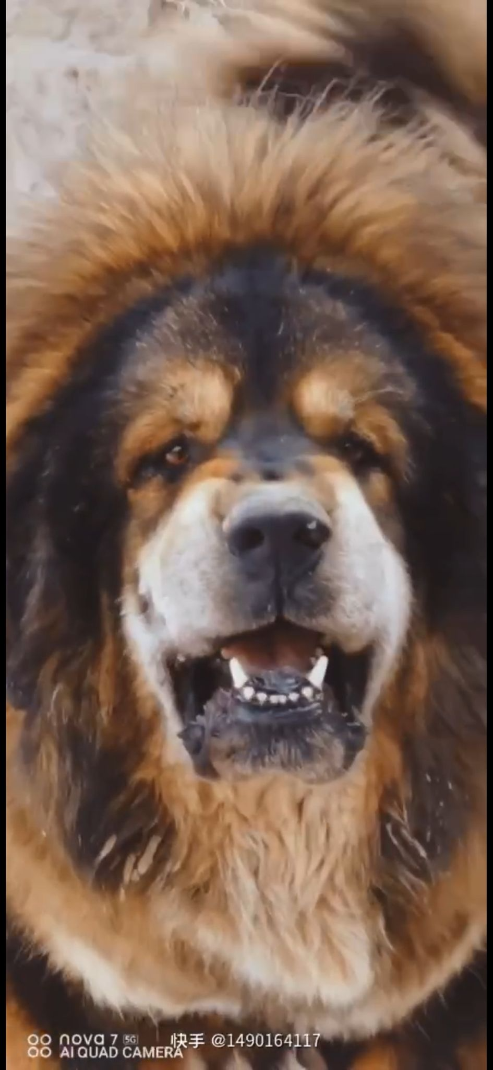Kyra Dorjee

Dorjee is a truly one-of-a-kind male, proudly coming from the renowned Jin Tai Kennel. A large and impressive male, he carries tremendous substance, bone, and presence.

His rich sable coat is a crowd favourite, turning heads wherever he goes. Dorjee possesses a beautiful, well-defined head that perfectly complements his powerful structure and overall balance.

Even at this stage, his offspring are already making a strong mark in India — a testament to his quality and prepotency.

We are extremely proud of this stud and his role in helping preserve and promote the true essence of the Tibetan Mastiff.

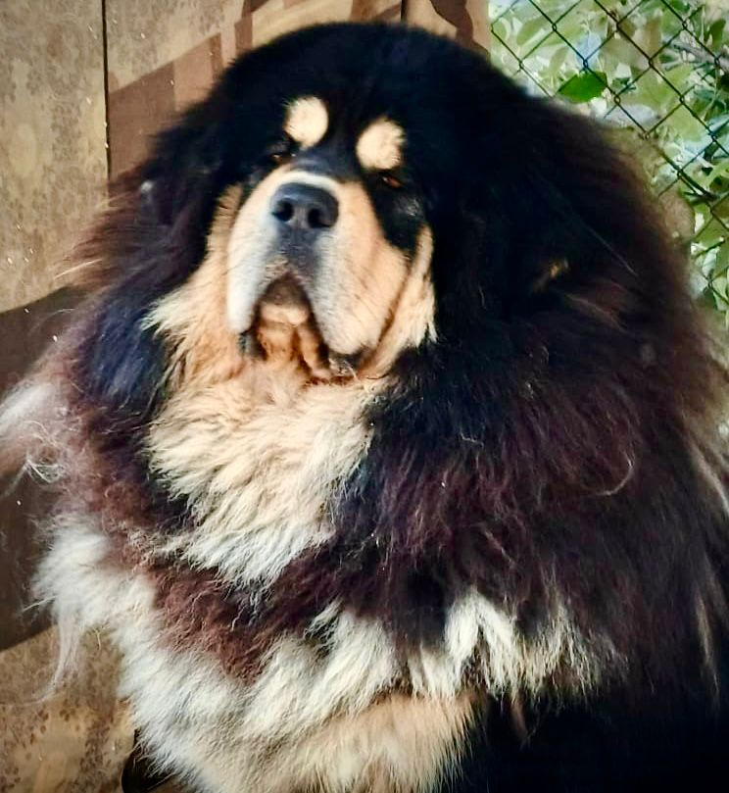Kyra Bale

Kyra Bale comes all the way from China, originating from one of the oldest Hequ Tibetan Mastiff conservation centres. Rooted in authentic bloodlines, Bale represents heritage, strength, and true breed type.

His magnificent lion-like mane makes him a standout and one of the favourites at our kennel. Compact, powerful, and highly athletic, Bale combines substance with agility — a rare and valuable balance.

He has been a cornerstone in improving and strengthening the breed in India, consistently passing on type, structure, and presence to his offspring.

Beyond his commanding appearance, Bale possesses one of the most loving and stable temperaments, making him not only an exceptional stud but also a wonderful companion.

We are proud and excited to have him contributing toward the preservation of the true Tibetan Mastiff.

